

Requirements Analysis &
System Modeling
Online Course Registration System

Basmala Salah Mohamed
Rana Abdelhamid Dief

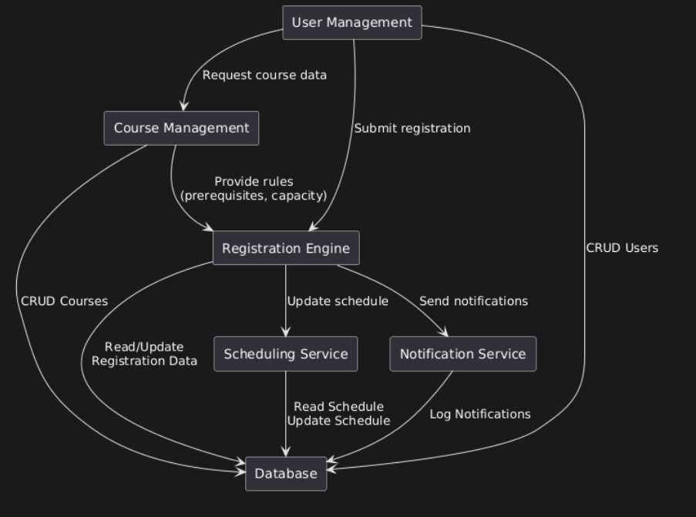
Component Diagram:

